Outdoor imperial - 122cm Target Face - Dozens of arrows
5 Zone Scoring | 9 |  | 7 |  |  | 5 |  | 3 |  |  | 1
Round Yards | 100 | 80 |  | 60 | 50 |  | 40 |  | 30 | 20 |  | 10
York | 6 | 4 |  | 2
Hereford |  | 6 |  | 4 | 2
Bristol I |  | 6 |  | 4 | 2
Bristol II |  |  |  | 6 | 4 |  | 2
Bristol III |  |  |  |  | 6 |  | 4 |  | 2
Bristol IV |  |  |  |  |  |  | 6 |  | 4 | 2
Bristol V |  |  |  |  |  |  |  |  | 6 | 4 |  | 2
St. George | 3 | 3 |  | 3
Albion |  | 3 |  | 3 | 3
Windsor |  |  |  | 3 | 3 |  | 3
Windsor 50 |  |  |  |  | 3 |  | 3 |  | 3
Windsor 40 |  |  |  |  |  |  | 3 |  | 3 | 3
Windsor 30 |  |  |  |  |  |  |  |  | 3 | 3 |  | 3
New Western | 4 | 4
Long Western |  | 4 |  | 4
Western |  |  |  | 4 | 4
Western 50 |  |  |  |  | 4 |  | 4
Western 40 |  |  |  |  |  |  | 4 |  | 4
Western 30 |  |  |  |  |  |  |  |  | 4 | 4
American |  |  |  | 2.5 | 2.5 |  | 2.5
St. Nicholas |  |  |  |  |  |  | 4 |  | 3
New National | 4 | 2
Long National |  | 4 |  | 2
National |  |  |  | 4 | 2
National 50 |  |  |  |  | 4 |  | 2
National 40 |  |  |  |  |  |  | 4 |  | 2
National 30 |  |  |  |  |  |  |  |  | 4 | 2
New Warwick | 2 | 2
Long Warwick |  | 2 |  | 2
Warwick |  |  |  | 2 | 2
Warwick 50 |  |  |  |  | 2 |  | 2
Warwick 40 |  |  |  |  |  |  | 2 |  | 2
Warwick 30 |  |  |  |  |  |  |  |  | 2 | 2

Outdoor Metric Rounds – Dozens of Arrows
10 Zone scoring | 10 |  | 9 |  | 8 |  | 7 |  | 6 |  | 5 |  | 4 |  |  | 3 |  | 2 |  | 1
 | 122cm Target Face |  |  |  |  |  |  |  |  |  |  | 80cm Target Face
Round Meters | 90 | 70 |  | 60 |  | 50 | 40 | 30 |  | 20 |  | 50 |  | 40 | 30 |  | 20 |  | 15 |  | 10
WA 1440 Gents | 3 | 3 |  |  |  |  |  |  |  |  |  | 3 |  |  | 3
WA 1440 Ladies/Metric I |  | 3 |  | 3 |  |  |  |  |  |  |  | 3 |  |  | 3
Metric II |  |  |  | 3 |  | 3 |  |  |  |  |  |  |  | 3 | 3
Metric III |  |  |  |  |  | 3 | 3 |  |  |  |  |  |  |  | 3 |  | 3
Metric IV |  |  |  |  |  |  | 3 | 3 |  |  |  |  |  |  |  |  | 3 |  |  |  | 3
Metric V |  |  |  |  |  |  |  | 3 |  | 3 |  |  |  |  |  |  |  |  | 3 |  | 3
WA Long Metric Gents | 3 | 3
Long Metric I/Ladies |  | 3 |  | 3
Long Metric II |  |  |  | 3 |  | 3
Long Metric III |  |  |  |  |  | 3 | 3
Long Metric IV |  |  |  |  |  |  | 3 | 3
Long Metric V |  |  |  |  |  |  |  | 3 |  | 3
Short Metric Gents |  |  |  |  |  |  |  |  |  |  |  | 3 |  |  | 3
Short Metric I/Ladies |  |  |  |  |  |  |  |  |  |  |  | 3 |  |  | 3
Short Metric II |  |  |  |  |  |  |  |  |  |  |  |  |  | 3 | 3
Short Metric III |  |  |  |  |  |  |  |  |  |  |  |  |  |  | 3 |  | 3
Short Metric IV |  |  |  |  |  |  |  |  |  |  |  |  |  |  |  |  | 3 |  |  |  | 3
Short Metric V |  |  |  |  |  |  |  |  |  |  |  |  |  |  |  |  |  |  | 3 |  | 3
Half WA 1440 Gents | 1.5 | 1.5 |  |  |  |  |  |  |  |  |  | 1.5 |  |  | 1.5
Half WA 1440 Ladies/Half Metric I |  | 1.5 |  | 1.5 |  |  |  |  |  |  |  | 1.5 |  |  | 1.5
Half Metric II |  |  |  | 1.5 |  | 1.5 |  |  |  |  |  |  |  | 1.5 | 1.5
Half Metric III |  |  |  |  |  | 1.5 | 1.5 |  |  |  |  |  |  |  | 1.5 |  | 1.5
Half Metric IV |  |  |  |  |  |  | 1.5 | 1.5 |  |  |  |  |  |  |  |  | 1.5 |  |  |  | 1.5
Half Metric V |  |  |  |  |  |  |  | 1.5 |  | 1.5 |  |  |  |  |  |  |  |  | 1.5 |  | 1.5
WA Standard Bow |  |  |  |  |  | 3 |  | 3
WA 70m |  | 6
WA 60m |  |  |  | 6
WA 50m |  |  |  |  |  |  |  |  |  |  |  | 6
WA 900 |  |  |  | 2.5 |  | 2.5 | 2.5

Indoor Rounds - Standard Target face
10 Zone scoring | 10 | 9 | 8 |  | 7 | 6 | 5 | 4 |  | 3 | 2 | 1
Round | Distance |  |  | Dozens of arrows |  |  |  |  | Target face
WA 18m | 18m |  |  | 5 |  |  |  |  | 40cm
WA 25m | 25m |  |  | 5 |  |  |  |  | 60cm
WA Combined | 18m |  |  | 5 |  |  |  |  | 40cm
 | 25m |  |  | 5 |  |  |  |  | 60cm
Stafford | 30m |  |  | 6 |  |  |  |  | 80cm
Andy Harris | 15y |  |  | 3 |  |  |  |  | 40cm
Bray I | 20y |  |  | 2.5 |  |  |  |  | 40cm
Bray II | 25y |  |  | 2.5 |  |  |  |  | 60cm
Portsmouth | 20y |  |  | 5 |  |  |  |  | 60cm

Indoor Rounds - Special Target faces
Round | Distance |  | Dozens of arrows |  |  | Target Style
Worcester | 20y |  | 5 |  |  | 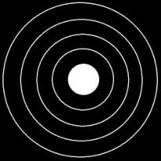
Scoring zones: | 5 | 4 | 3 | 2 | 1
Note: 5 arrows per end, target size is 40cm
Round | Distance |  | Dozens of arrows |  |  | Target Style
Vegas | 18m |  | 5 |  |  | 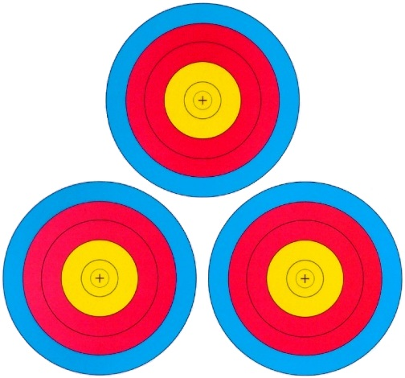
Scoring zones: | 10 | 9 | 8 | 7 | 6
Note: 1 arrow per target, arrows must be numbered, each target is 20cm

