Clacton Archers
Progress Awards and Badges

We have 4 different types of badges that can be earned, 2 during the indoor season and 2 during the outdoor season.

Outdoor season
Classifications
The outdoor classifications are 3rd class, 2nd class, 1st class, bowman, master bowman, and grandmaster bowman. These can be earned by achieving a high enough score for the round you are shooting. You will need to shoot 3 qualifying scores within the same outdoor season (1st of January to 31st of December) and submit all 3 countersigned score sheets to the records officer. The 3 rounds do not need to be the same type, for example you could submit a National, Long Metric and a Western.

If you are shooting an imperial round then only the first round of the day counts, however with metric rounds it doesn't matter how many shots or rounds you have had before the start of the round. The full list of rounds and scores is too long to include here, but they can be found in the Download Documents section on the club website https://clactonarchers.co.uk/download-documents/

The master and grandmaster ranks can only be earned if the 3 scores have been shot at competitions that have been granted record status.
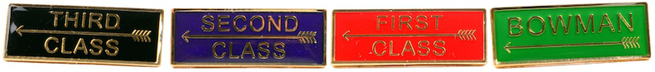

Progress awards
After six sighting arrows, you shoot three dozen arrows at a 122cm face using 5 zone scoring at a selected distance. This can be shot at 20, 30, 40, 50, 60, 80 or 100 yards with the aim of reaching the target score for that distance (please note that different scores apply for different bow types). Only the first 3 dozen arrows after your sighters will count, so you can’t claim more than 1 badge per day and only on the first distance shot that day. The score only needs to be reached once before the award can be claimed by handing in the countersigned score sheet to the records officer.

Distances | Recurve Score | Compound Score | Barebow Score | Longbow Score
20 yards | 252 | 290 | 180 | 160
30 yards | 252 | 290 | 180 | 150
40 yards | 252 | 290 | 170 | 140
50 yards | 252 | 290 | 160 | 120
60 yards | 252 | 290 | 150 | 100
80 yards | 252 | 290 | 140 | 80
100 yards | 252 | 290 | 130 | 60
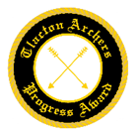
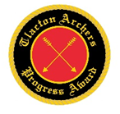
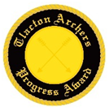
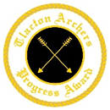
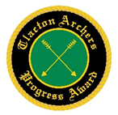
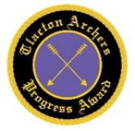
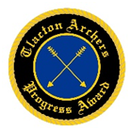

Indoor season
Classifications
Indoor classifications go from an A rank at the high end, down to an H rank at the low end and can be earned by achieving a high enough score for the round you are shooting. You will need to shoot 3 qualifying scores within the same Indoor season (1st of July to 30th of June the following year) and submit all 3 countersigned score sheets to the records officer to claim the rank and badge. The 3 scores do not need to be the same round so you can mix and match whichever rounds you want, for example 2 Portsmouth and 1 WA 18m score. If you are shooting an imperial round then only the first round of the day counts, however with metric rounds (WA rounds or a Vegas) it doesn't matter how many shots or rounds you have had before the start of the round.

The scores for recurve and compound can be found below, and apply to all ages. Barebow and Longbow don’t officially have rankings indoors (even though people have been asking AGB for years) so as a club we use the recurve chart for those categories.
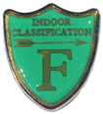
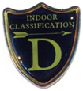
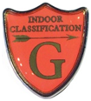
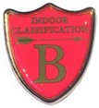
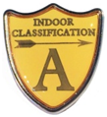
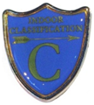
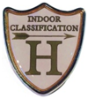

Recurve |  |  |  |  |  | Full-size faces |  |  | Triple faces
Women | Bray  I | Bray  II | Portsmouth | Stafford | Worcester | WA  18m | WA  25m | WA  Combined | WA 18m  or Vegas | WA  25m | WA  Combined
A | 279 | 284 | 582 | 682 | 293 | 560 | 562 | 1122 | 560 | 562 | 1122
B | 270 | 276 | 569 | 663 | 285 | 541 | 545 | 1086 | 541 | 545 | 1086
C | 243 | 254 | 534 | 609 | 259 | 489 | 496 | 985 | 479 | 489 | 968
D | 202 | 218 | 479 | 521 | 218 | 407 | 417 | 824 | 347 | 363 | 711
E | 134 | 156 | 380 | 360 | 150 | 274 | 281 | 555 | 182 | 189 | 370
F | 74 | 89 | 255 | 190 | 85 | 153 | 150 | 304 | 86 | 84 | 170
G | 36 | 41 | 139 | 76 | 41 | 74 | 65 | 139 | 38 | 33 | 71
H | 23 | 25 | 93 | 43 | 27 | 48 | 39 | 86 | 24 | 19 | 43
Men
A | 288 | 291 | 592 | 699 | 298 | 576 | 578 | 1155 | 576 | 578 | 1155
B | 279 | 284 | 582 | 682 | 293 | 560 | 562 | 1122 | 560 | 562 | 1122
C | 258 | 267 | 554 | 639 | 273 | 518 | 523 | 1041 | 516 | 522 | 1039
D | 221 | 235 | 505 | 563 | 237 | 446 | 454 | 900 | 410 | 425 | 836
E | 168 | 188 | 432 | 444 | 184 | 340 | 350 | 690 | 254 | 266 | 521
F | 100 | 119 | 315 | 266 | 114 | 205 | 208 | 413 | 124 | 125 | 248
G | 53 | 63 | 195 | 125 | 61 | 109 | 102 | 211 | 58 | 54 | 112
H | 36 | 41 | 139 | 76 | 41 | 74 | 65 | 139 | 38 | 33 | 71

Compound |  |  |  |  |  | Full-size faces |  |  | Triple faces
Women | Bray  I | Bray  II | Portsmouth | Stafford | Worcester | WA  18m | WA  25m | WA  Combined | WA 18m  or Vegas | WA  25m | WA  Combined
A | 279 | 281 | 570 | 672 | 299 | 558 | 558 | 1116 | 558 | 558 | 1116
B | 274 | 277 | 562 | 663 | 296 | 549 | 550 | 1099 | 549 | 550 | 1099
C | 259 | 265 | 544 | 636 | 279 | 520 | 523 | 1043 | 519 | 523 | 1042
D | 229 | 241 | 509 | 577 | 247 | 461 | 468 | 929 | 438 | 451 | 889
E | 182 | 201 | 449 | 477 | 200 | 368 | 379 | 747 | 292 | 306 | 598
F | 117 | 137 | 347 | 312 | 132 | 238 | 243 | 482 | 150 | 154 | 304
G | 57 | 68 | 206 | 136 | 65 | 117 | 111 | 227 | 63 | 59 | 122
H | 42 | 49 | 160 | 93 | 49 | 87 | 78 | 165 | 45 | 40 | 85

Compound |  |  |  |  |  | Full-size faces |  |  | Triple faces
Men | Bray  I | Bray  II | Portsmouth | Stafford | Worcester | WA  18m | WA  25m | WA  Combined | WA 18m  or Vegas | WA  25m | WA  Combined
A | 284 | 284 | 581 | 684 | 300 | 568 | 568 | 1136 | 568 | 568 | 1136
B | 279 | 279 | 570 | 672 | 299 | 558 | 558 | 1116 | 558 | 558 | 1116
C | 268 | 269 | 554 | 652 | 289 | 537 | 539 | 1075 | 537 | 539 | 1075
D | 246 | 249 | 529 | 609 | 264 | 493 | 498 | 991 | 486 | 494 | 980
E | 210 | 215 | 484 | 534 | 226 | 420 | 429 | 850 | 370 | 386 | 757
F | 148 | 152 | 396 | 388 | 162 | 295 | 304 | 599 | 203 | 212 | 415
G | 86 | 86 | 279 | 218 | 96 | 173 | 172 | 345 | 100 | 98 | 198
H | 58 | 55 | 206 | 136 | 65 | 117 | 111 | 227 | 63 | 59 | 122

Portsmouth
Portsmouth badges are awarded once you shoot at or above the corresponding score on the badge when shooting a Portsmouth round, which is 5 dozen arrows shot on a 60cm target face at 20 yards. You can have 6 sighters as usual, but a Portsmouth needs to be the first round you shoot that day, and if you shoot more than 1 Portsmouth only the first one will count towards badges. The score only needs to be reached once before the award can be claimed by handing in the countersigned score sheet to the records officer.

The scores that can have a badge claimed start at 300 and go up by 25 points each time until 575, then up by 5 points until a maximum (perfect) score of 600.
